**CAP 10 031**

**Maypole Gardens Refurbishment 2024/2025**

**Before Refurbishment Photographs.**

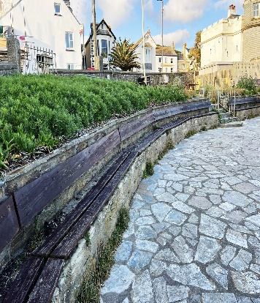

Seating General View of planting Fencing

Seating area Electric Box Paving

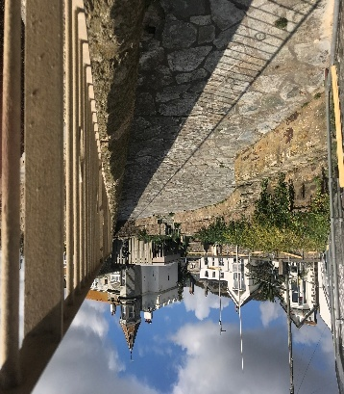

General view General View Paving and Planting

**CAP 10 031**

**Maypole Gardens Refurbishment 2024/2025**

**Construction Photographs.**

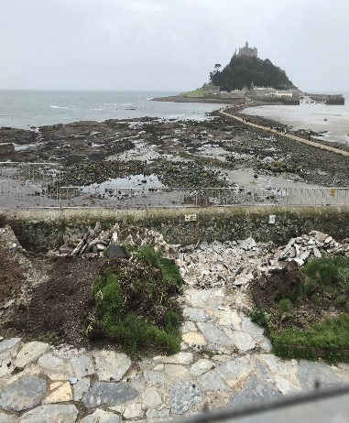

Preparation Preparation Preparation

Scraping Scraping Scraping and frame build

Concrete poor Concrete and block work Block work preparation

Block work and slab laying Slab laying and seating Middle section build

Coming together Top section view Lower tier view seating

Top section view planters View top section slab laying Nearing completion

**CAP 10 031**

**Maypole Gardens Refurbishment 2024/2025**

**Completion Photographs.**

Just before completion Railings installed View from accessibility gate

View from accessibility gate View with railings Lower tier looking up

Dolphin statue Social media post completion